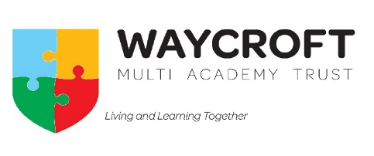

Waycroft Academy’s approach to homework

This guidance is based on guidelines which emphasise the importance of homework and how it helps children to learn. Homework should be an enjoyable activity for the pupils in which they consolidate their learning at school. The time spent on homework should be age appropriate and not excessive.
Research from the Education Endowment Foundation finds that … ‘homework is positive across both primary and secondary school…The quality of the task set appears to be more important than the quantity of work required from the pupil.’
With this is mind, we have worked together as a team of staff to bring a more consistent approach to what the children are set as homework, to aid them in getting into routines but to also ensure it is directly linked to what they are learning each week (becoming an integral part of learning) and therefore building on their fluency and knowledge. We have prioritised areas of need for our school, where the children often need more regular practice.
Reading:
For Reception-Y6, all children will be expected to read a minimum of 3 times per week (ideally 5), getting an adult to sign their diary. In KS2, expectations will be made on how long each reading session should be in order to improve reading stamina as books get harder and longer.
Spelling:
Each year group (from Y2) will be given spellings to practise at home each week using one of the given spelling strategies. The spellings will be tested each Thursday and will also be taught at least 3 times per week in school. Year 1 will have a phonics style homework, to reinforce sounds they have been learning that week and will have a few spellings to practise linked to the sounds they have been learning or linked to common exception words.
Maths:
Children in years 2-6 will be expected to go onto Times Tables Rockstars (TTRS) each week (from T4 in year 2) to practise their times tables. This may be practising certain set tables that they have been focussing on class that week, or it may be all tables up to 12x12 once they are in year 4 or above. Year groups will give information on what area of TTRS they would like the children to use each week.
*In year 6, children may also receive some arithmetic/reasoning style question practice relevant to what they have been taught that week, where appropriate and in preparation for secondary school expectations.
By making homework standardised from Y1-Y6, we hope that children will get into a good routine early on and will begin to embed their skills learned in the classroom at home.
All homework from Y1-Y6 will be handed out on a Thursday and will be collected in on a Tuesday to support routines for families and the children.

**On occasion, year groups may set a topic style homework, which will be set over a longer period.

