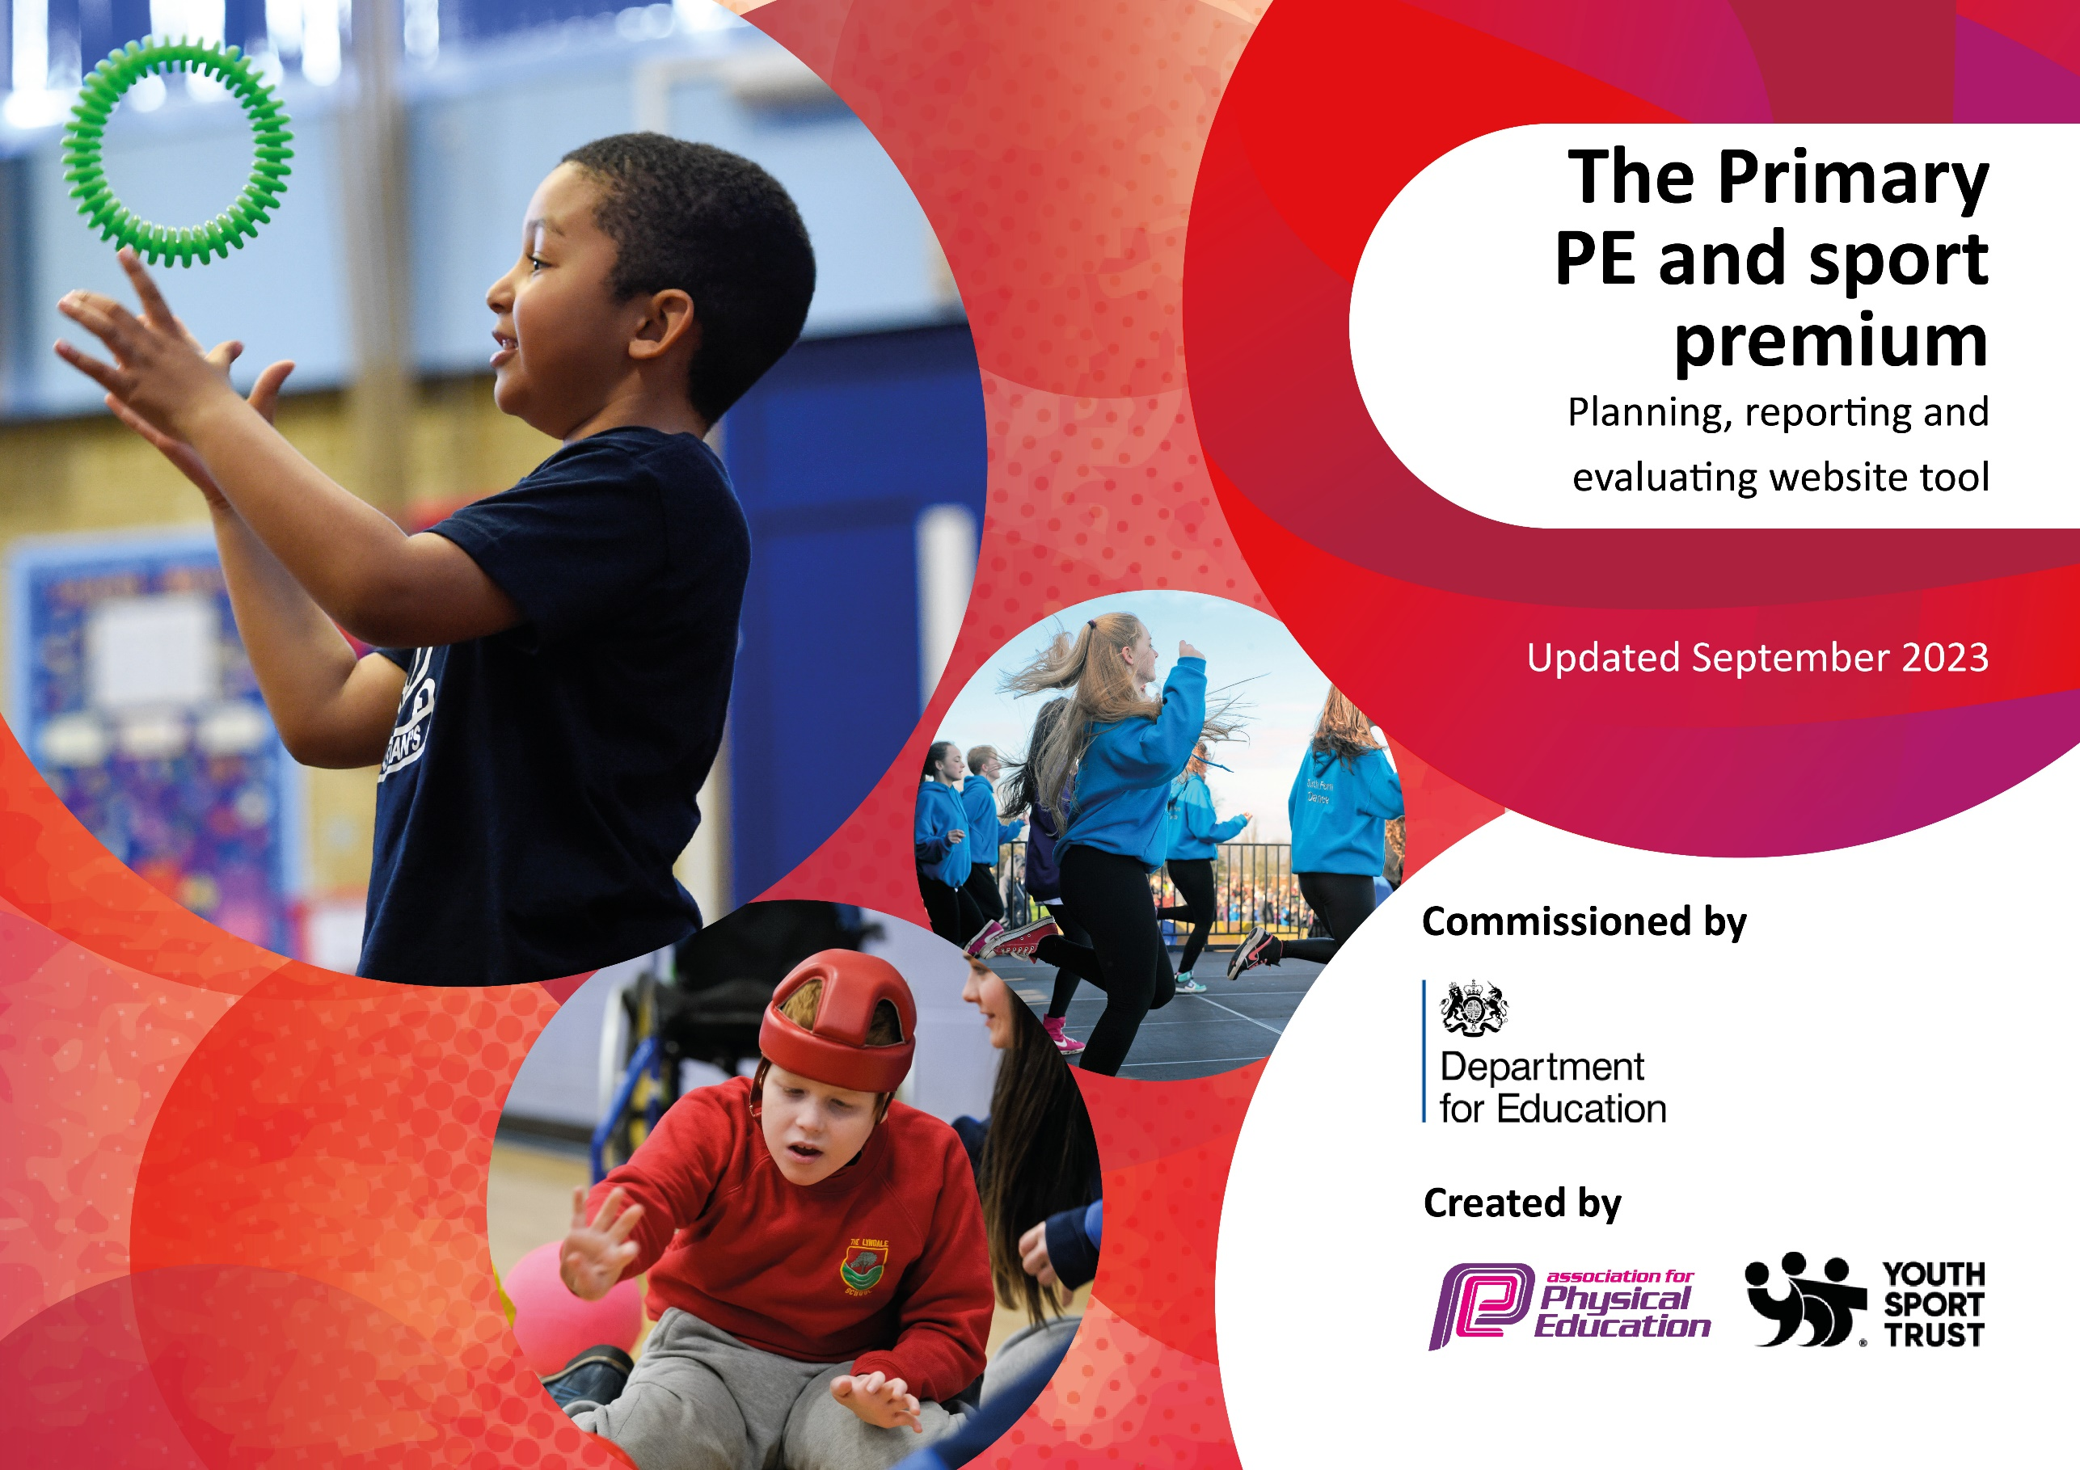

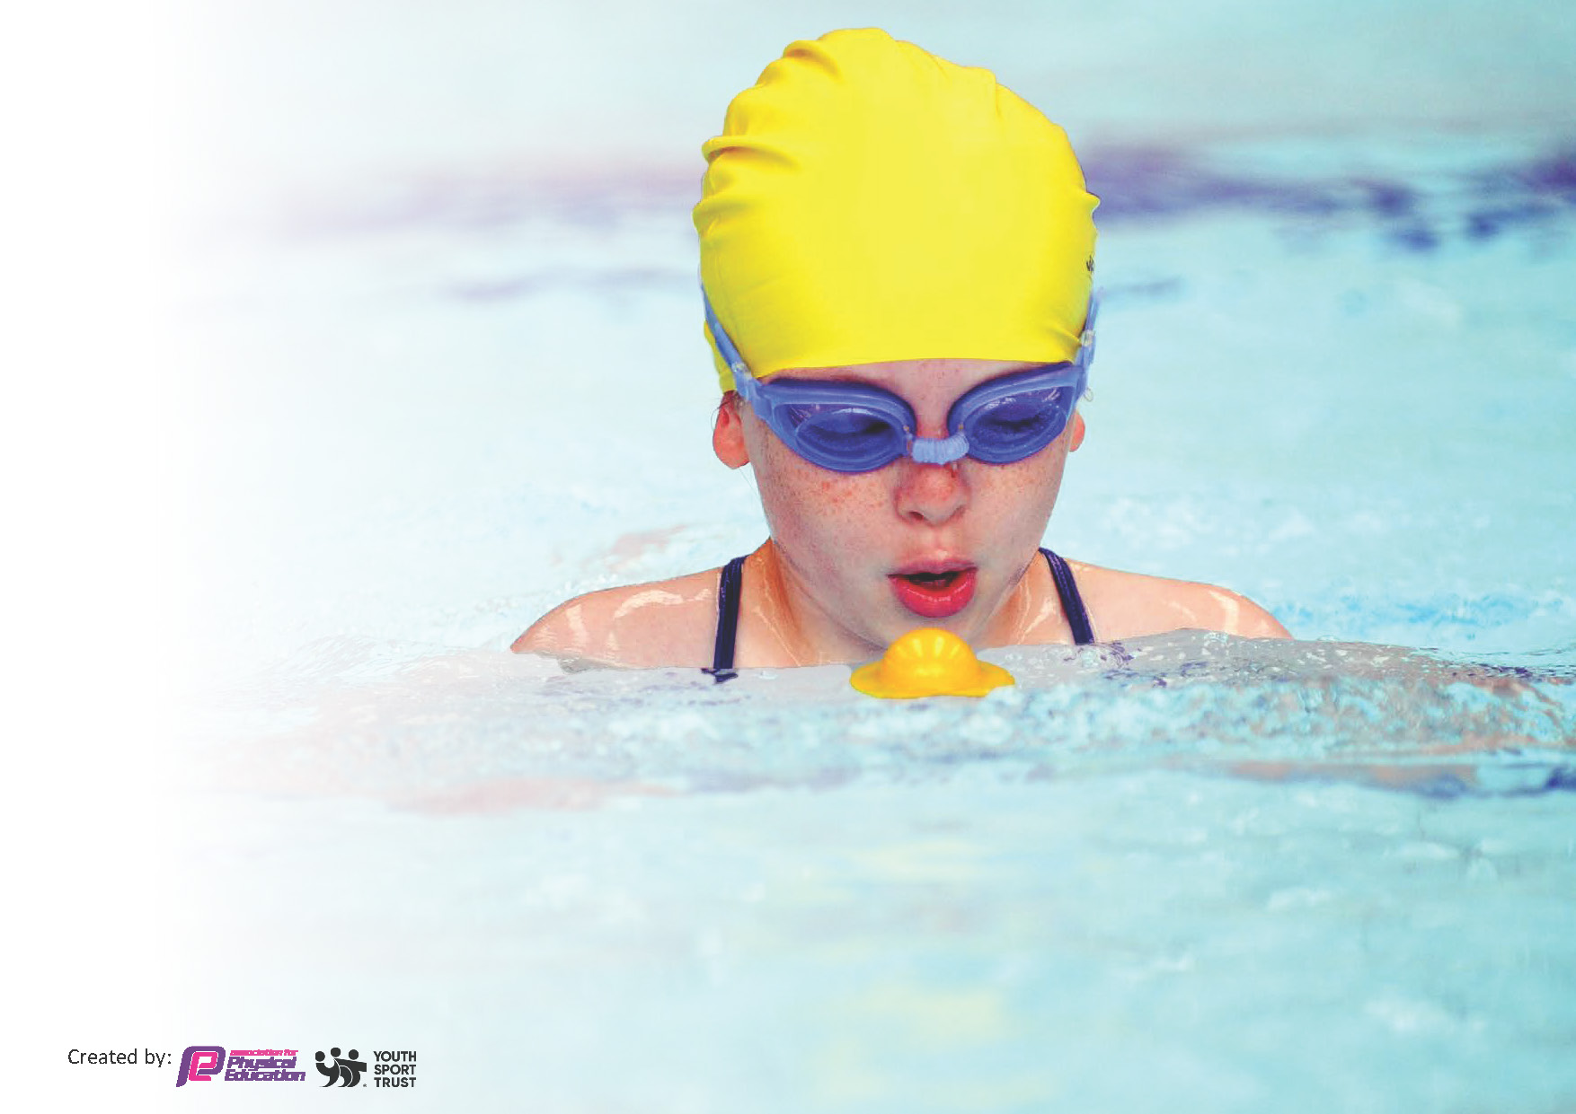
This template can be used for multiple purposes:
by:
- It enables schools to effectively plan their use of the Primary PE and sport premium
- It helps schools to meet the requirements (as set out in guidance) to publish information on their Primary PE and sport premium
- It will be an effective document to support Ofsted inspections enabling schools to evidence progress in Physical Education (PE) and evidence swimming attainment, which forms part of the PE National Curriculum. We would recommend schools consider
the Intent, Implementation and Impact of any spend, as examined within the Education Inspection Framework.

It is important that your grant is used effectively and based on school need.

Schools must use the funding to make additional and sustainable
improvements to the quality of the PE, School Sport and Physical Activity (PESSPA)
they offer. This means that you should use the Primary PE and sport premium to:

- Build capacity and capability within the school to ensure that improvements made now will benefit pupils joining the school in future years
- Develop or add to the PESSPA activities that your school already offers.

The Primary PE and sport premium should not be used to fund capital spend projects; the school’s core budget should fund these. Further detail on capital expenditure can be found in the updated Primary PE and sport premium guidance.

The Primary PE and sport premium guidance, outlines 5 key priorities that funding should be used towards. It is not

necessary that spending has to meet all the key priorities, you should select the priorities that you aim to use any funding towards.

Although completing this template is not a requirement for schools, schools are required to publish details of how they spend this funding. Schools must also outline what the impact this funding has had on pupils’ PE and sport participation and attainment and how any spending will be sustainable in the future. All funding must be spent by 31st July 2024.

The Department for Education has worked closely with the Association for Physical Education (afPE) and the Youth Sport Trust (YST) to develop this template and encourages schools to use it. This template is an effective way of meeting the reporting requirements of the Primary PE and sport premium.
Review of last year’s spend and key achievements (2022/2023)

We recommend you start by reflecting on the impact of current provision and reviewing your previous spend.
Activity/Action | Impact
- We offer a range of after-school sporting clubs that are well attended by our pupils which have led to competitions, festivals and performances beyond school.  - The lead playmaker and Sports Council members have worked together to make lunchtimes more active and competitive for the children at the school.  - PE equipment has been replenished to match planning and to ensure a safe and high quality delivery of PE lessons. Teachers were consulted to ensure their year group has enough items of equipment for their lessons.  - PE hall mats have been purchased for the school hall, replacing the broken, old and heavy mats.  - Staff have all taught updated indoor and outdoor PE planning and continue adapt this to meet the needs of all pupils.  - All teaching staff received CPD training for Dance.  - Year 1, 3 and 5 have had swimming lessons this academic year. The same year groups will continue to have swimming lessons next year. | - Children for whom we are in receipt of PP can attend one club FOC. All pupils have access to a variety of sports and we are building links to clubs within the community.  - Children now have access to a variety of activities during lunchtimes. One of the club providers runs some lunchtime activities on some days.  - Children have access to sports and gym equipment which supports a broad PE curriculum.  - All children can at least share one mat between two in PE lessons and there are enough mats overall for two classes to access at the same time.  - Children are accessing a progressive and well sequenced PE curriculum which covers a range of sports, dance, gymnastics and orienteering.  - The teachers are more confident at delivering dance lessons, following CPD.  - A plan is in place to improve 25m outcome at the end of Year 6, over coming years.

Swimming Data
Meeting National Curriculum requirements for swimming and water safety.
Priority should always be given to ensuring that pupils can perform safe self-rescue even if they do not fully meet the first two requirements of the National Curriculum programme of study

Question | Stats: | Further context  Relative to local challenges
What percentage of your current Year 6 cohort (2022-23) can swim competently, confidently and proficiently over a distance of at least 25 metres? | 55% | A good number of children did not have swimming lessons during Covid. We have reacted to this by providing swimming lessons for Years 1, 3 and 5 for 2022-23 and this will continue in this academic year.
What percentage of your current Year 6 cohort can use a range of strokes effectively [for example, front crawl, backstroke, and breaststroke]? | 43% | Use this text box to give further context behind the percentage.  e.g., Even though your pupils may swim in another year please report on their attainment on leaving primary school at the end of the summer term 2024

What percentage of your current Year 6 cohort are able to perform safe self-rescue in different water-based situations? | 40% | Use this text box to give further context behind the percentage.
If your schools swimming data is below national expectation, you can choose to use the Primary PE and sport premium to provide additional top-up sessions for those pupils that did not meet National Curriculum  requirements after the completion of core lessons. Have you done this? | Yes/No | We have not so far but we will consider this when we look at the outcomes this year.
Have you provided CPD to improve the knowledge and confidence of staff to be able to teach swimming and water safety? | Yes/No | This is provided by the local swimming pool.

Key priorities and Planning Total Sports Premium Grant = £19, 530
This planning template will allow schools to accurately plan their spending.

Action – what are you planning to do | Who does this action impact? | Key indicator to meet | Impacts and how sustainability will be achieved? | Cost linked to the action
Engage with ‘Bristol Sports Foundation’ in order to put in place high quality gymnastics lessons, CPD for staff and quality after-school club. | Staff will be provided with CPD by observing high quality gymnastics coaching and leading sessions themselves.  Pupils will get high quality gymnastics lessons for at least one short term as well as possible access to afterschool gym clubs and competitions/festivals. | 1. Increased confidence, knowledge and skills of all staff in teaching PE and sport.  3. The profile of PE and sport is raised across the school as a tool for whole school improvement.  4. Broader experience of a range of sports and activities offered to all pupils. | This will impact all children across KS1 and KS2. Future use of Sports Premium will include subscription to Bristol Sports Foundation in order to develop the relationship and maintain sustainability. This will include gymnastics until it becomes a strength within the teaching team. | £6641.70
Develop our involvement with Ashton Park Sports Partnership. | Children across KS1 and KS2 will have access to a variety of local competitions and festivals. This will include a focus for both girls and boys. | 4. Broader experience of a range of sports and activities offered to all pupils  5. Increased participation in competitive sport | This will impact a good number of children across KS1 and KS2. Annual membership to local sports partnership for sustainability. PE Leader is given regular leadership time during the year to plan events for SSP. | £2050
Contribute towards the cost of swimming pool hire and transport. | It will immediately impact the children in Years 1, 3 and 5 this year. | 2. Engagement of all pupils in regular physical activity  4. Broader experience of a range of sports and activities offered to all pupils | We will continue with Years 1, 3 and 5 until our 25m outcome in Year 6 is 85% +. | £3000
Access to additional high quality coaching and support at competitions and events from Grassroots Sports Organisation. | This will immediately impact all children across the school at lunchtimes. There will also be impact for all children who access competitions and festivals run by either Bristol Sports Foundation or Ashton Park Sports Partnership. | 2. Engagement of all pupils in regular physical activity  3. The profile of PE and sport is raised across the school as a tool for whole school improvement.  4. Broader experience of a range of sports and activities offered to all pupils.  5. Increased participation in competitive sport | Grassroots Sports is a local community organisation who also run holidays and after school clubs so this has an impact on pupils, parents and community. | £2000
Provide focused lunchtime adult-led sports sessions that offer a range of sports to girls, boys and both genders. | All children in KS1 and KS2 who choose to participate; there will also be some groups where children are targeted for participation. | 2. Engagement of all pupils in regular physical activity  5. Increased participation in competitive sport | Our lunchtime staff will observe some sessions so they could continue if this is not financially sustainable in the future. | £1560 ( 39 weeks at £40 per week)
Upgrade the quality of sports equipment available at Waycroft, including goal posts/nets, maintenance of gymnastics equipment/frames and general consumables. | Immediate impact on all pupils and staff in continuing to have access to the resources and equipment needed to deliver a broad curriculum and additional lunchtime provision. | 2. Engagement of all pupils in regular physical activity | Ongoing costs with sustainability built in through regular auditing of equipment to ensure everything is kept up to date etc. | £2000
Provide high quality dance workshops from ‘Education Group’ or similar which link in with the substantive and disciplinary knowledge of our history/geography/science curriculum. | Immediate impact on all pupils involved (planned for at least three year groups, possibly all year KS1 and KS2 year groups. | 4. Broader experience of a range of sports and activities offered to all pupils. | Build this cost into our use of sports premium each year. | £1500
Total spend planned for 2023-24 |  |  |  | £18,751.70
Amount left as contingency (possibly to be used for transport to SSP and Bristol Foundation festivals/competitions) |  |  |  | £778.30

Signed off by:

Head Teacher: | Adam Smith
Subject Leader or the individual responsible for the Primary PE and sport premium: | Hayley Morris
Governor: | Albany Boulter
Date: | 23.09.2023

Key achievements 2023-2024
This template will be completed at the end of the academic year and will showcase the key achievements schools have made with their Primary PE and sport premium spending.

Activity/Action | Impact | Comments

