Dear Mothers, Fathers and Carers

Booking parents’ evening appointments –the appointment books will be kept in the reception foyer from Thursday 2nd February until the end of Term 3. The parents’ evenings for Term 4 will take place in the first week back on Tuesday 21st and Wednesday 22nd February.

School Bank: These are the dates that the school bank will be open for the rest of this academic year;
27th January, 24th February, 31st March, 28th April, 26th May and 30th June between 8.15am and 8.45am. Children in Years 3-6 can open an account with as little as £1; they can pay their money in at school on the above dates; each child will receive an HSBC money box on opening their account. It can be used as they grow and move schools to secondary and further.

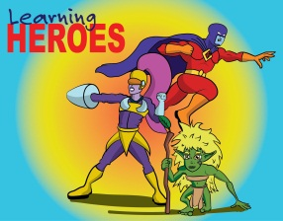
Learning Heroes – We have two groups of learning heroes to report in this newsletter. On 13th January, in our Achievement Assembly, the following children were awarded as learning heroes
Yr 3; Kezzie-Mae & Ellie R.
Yr 4; Josh E & Spencer.
Yr 5; Megan & Koby.
Yr 6; Amber, Libby D & Charlie.
Then on 20th January, the following were also awarded as learning heroes;
Yr 1: Anthony & Lily. Yr 2: Scarlett & Huw.
Yr 5: Alfie O & Thomas H. Yr 6: Ruby-Mae, Ross & Holly. Well done to all our children for showing their use of ‘building learning power’.

Tech Takeover at Stockwood Library – On Thursday 16th February between 1.30pm and 4.30pm Stockwood Library are holding the perfect afternoon for 8-11 year olds with their tech takeover. There will be code club, toy robotics, minecraft and more! For more information, contact the library on 0117 9038546.

Race for Life this year will take place on Saturday 24th June 2017 - Keep the date free! More details will follow later in the year.

Star Wars Menu – The children certainly seemed to enjoy the special han burgers, C-3PO chipped wedges and Chewbacca cheesy pizza we had on Thursday 19th January. We gave away some Star Wars prizes to randomly selected children who booked a lunch. Congratulations to George and Ollie in Yr 2, Alannah and Tiegan in Yr 4 and Sebastian and Thomas R in Yr 5 who were chosen as winners by the random number generator.

On Friday March 3rd from 10.45 am until lunch, we will be taking Year 4 to Stockwood Library to meet author Anna Wilson. Anna is a local author and hugely entertaining. She is happy to sign any books the children might have at home, or buy themselves to bring along.

‘How are we doing?’ Open Forum Meeting for Parents and Carers on Wednesday 8th February between 2.30pm and 3.30pm. Please do pop in and speak to us.

Sainsbury’s - Active for Kids vouchers. We are once again collecting these tokens – please find the voucher collection tub in the foyer. Thank you for all those donated so far.
Open Day – Thank you to all those parents and carers who came to visit on our open day and gave such positive feedback. We hope you enjoyed the time spent in the classrooms and found the visit both valuable and informative. The feedback forms have been collated and the results can be found on the attached form.

Holiday Club “ANCORA Treasure Seekers” - Stockwood Free Church (Baptist) in Ladman Road is once again laying on an action-packed, fun-filled club at half term. The dates will be Tuesday 14 to Friday 17 February. We start at 10.00 each day and finish at 12.30. All children of primary school age are very welcome to come along. Please, if you possibly can, register beforehand – you can obtain a form by Email from p_t_morse@hotmail.com or our website stockwoodfreechurch.org however we are always very happy to see you on the door! It'll be a great week, so do join us.

In March, the Green Team have invited Bristol Textile Recycling to collect any unwanted clothes. In return they will pay us for every bag of unwanted clothes we collect. This money will help the Green Team to buy new items such as litter pickers to make our school even more environmentally friendly. Please start saving your clothes now! Thank you, the Green Team.

Spelling Workshops – During our two parents’ evenings (Tuesday 21st & Wednesday 22nd February) Miss Morse will be running four 30 minute 'drop in' Spelling Workshops. If you feel you would like some support in helping your child to learn to spell then come along to the New Hall and join in one of the sessions below. During the session Miss Morse will be giving an interactive talk to explain the Look, Say, Cover, Write, Check method; with the opportunity to ask questions. The aim will be to explain clearly how to help your child and to explore new games and ideas to make the learning fun and effective.
Held in the New Hall, Workshop times: Tuesday 21st Feb: 3.30 - 4.00pm, 5.00 - 5.30pm, Wednesday 22nd Feb: 3.30 - 4.00pm, 5.00 - 5.30pm.
22nd February is the Scout and Guide movements Founder's Day. If children who are Rainbows, Brownies, Guides, Beavers, Cubs or Scouts would like to wear their uniforms instead of school uniform that day, they can. All other children to be in normal school uniform.

Applications for Nursery – If your child turns three before September 2017 and you would like them to join our nursery, please ensure your application form is returned before the end of February.

Camps – Information regarding Barton Camp and Hooke Court Camp will be sent home next week. Please check parentmail for the relevant email. This will be for current Year 2 and Year 3 children only. The information for Simonsbath for current Year 5 children has already been sent out detailing payment information and when the deposit is due (17th February). Please note, that once you have paid your deposit, you can log into parentpay and make any additional payments as and when you are able to, ensuring the full payment is made before the deadline for the relevant camp.

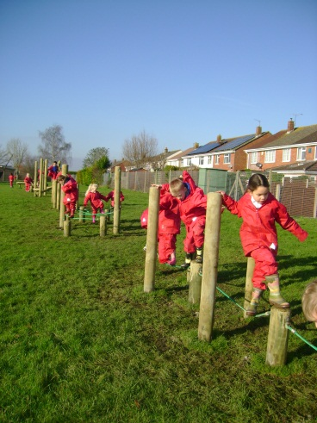
Trim Trail – It has been fantastic to see the children enjoying the trim trail. We have had some wonderful feedback from all year groups who have been on the field enjoying the additional equipment at lunch times. Thank you once again to the Friends of Waycroft for funding this project.

Quiz Night – One of our local scout groups will be holding a quiz night on Saturday 4th February at the Harrington Rd scout hut. Doors open at 7pm for a 7.30 start. Tickets are £2 if purchased in advance or £2.50 on the night. Adults only, max 6 per team, bar and raffle on the night. All profits raised go towards renovations for the scout hut. Email group@1ststockwoodscouts.org.uk for details.

Yours sincerely
Lisa Craig
Head of School

