Dear Mothers, Fathers and Carers

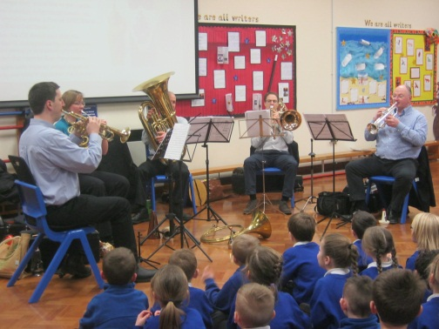
Musical Treat - We were privileged last term to have a visit from a group of professional brass players from St Georges Brandon Hill. They performed a concert for us, which was very well received by both children and staff.

Founders’ Day – It was lovely to see so many of our children wearing their Scouts, Guides, Brownies & Cubs uniform to school on 22nd February. The children looked very smart and were a credit to their packs.

Coffee Morning – The Friends of Waycroft are holding a coffee morning on Friday 10th March between 9am and 11am. Come and meet our small and friendly team of parents and find out more about what they do and how you can help. Younger children are welcome to attend too.

BLP Focus – Following on from the information sheet sent home to parents last week regarding Building Learning Power, we will now be featuring a different focus in each of our newsletters with examples of what the muscle could look like at home. This week the BLP muscle focus is: Absorption.
This means being able to lose yourself in learning-you may not be aware of the passing of time.
Over the next two weeks can you absorb yourself in a task at home by:
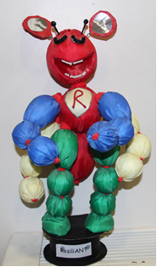
-Reading your book and stopping once you think 15 minutes has passed. Have you lost track of time and become absorbed?
-Playing a board game as a family
-Writing a poem together
-Building a (Lego/Micano) model
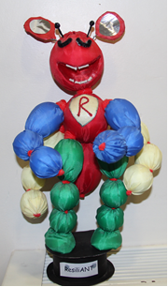
Let us know what you have done as a family, you could blog about it (don't forget to tag it BLP) or send us a picture!

Friday 24th March is Red Nose Day – For Comic Relief this year, we are asking children to wear something red. We will be collecting donations in a slightly different way this March. Rather than entering through the KS1 and KS2 playgrounds, we are asking all children to enter through the main reception on red nose day and go to the old hall. In the hall we will have giant red noses which the children can place their donations onto before they go to their classrooms. Comic Relief is a charity which schools up and down the country have been supporting for over two decades. To find out more about where the funding goes for this fantastic charity, please visit the following website: http://www.comicrelief.com/what-we-do

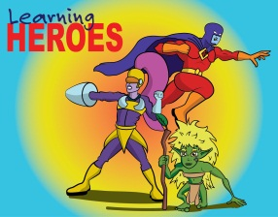
Learning Heroes – On 24th February, in our Achievement Assembly, the following children were awarded as learning heroes
Yr 1; Ruby M and Millie.
Yr 2; Harry and Farryl.
Yr 5; Callum and Harry D.
Yr 6; Thuuva, Laura S & Tin.
Well done to all our children for showing their use of ‘building learning power’.

Secret Mother’s Day Gift Sale – The Friends of Waycroft will be selling gifts for £2.50 each on the following dates; Wednesday 22nd March and Friday 24th March between 3.15pm & 4.15pm. As well as lunchtime on the Friday too; 11.30am – 1.15pm. Choose a gift for someone special. All gifts will come wrapped with a gift label. Maximum of two gifts per child.

Zootropolis Film Night – Thank you to the Friends of Waycroft for organising this entertaining evening. They raised £409 from this event. Details of how this money will be spent and future purchases will be available in up and coming newsletters issued by the Friends directly.

Clubs – All current school-led clubs will finish the week commencing 27th March. During this same week, the clubs letter for Terms 5 & 6 will be issued. All reply slips will need to be returned to the school office by 3rd April. They will be collated and reply slips issued during the first week back of Term 5, meaning clubs will start the week commencing 1st May (after May Day) for the last two terms of the academic year.

Change to details – If you have changed address, telephone number or e-mail, please don’t forget to inform us. In order for our communications to get through successfully, we need to ensure we have all the correct information on file.

‘Stages’ - Our Year 1 dancers who have been attending dance club each week performed on Sunday 26th February in a wonderful show at the Colston Hall. It is a weekend of dance which sees over 50 schools and dance clubs from around Bristol performing on stage. Waycroft dancers performed to the piece ‘A Whole New World’ from the Disney film Aladdin. The children performed brilliantly, we were so proud of their commitment and behaviour whilst representing our school. A special thank you to Miss Fish for running our Dance Club, and for organising for Waycroft to participate in this wonderful event.

Camp Payments – This Friday, 3rd March, is the final date for Year 3 parents to sign their child up for the Hooke Court camp taking place in October 2017. A £20 deposit is required to secure your child’s place. Remember, that all parents of children attending any of our camps (Barton, Hooke Court and Simonsbath) can sign into parentpay and continue to pay in manageable instalments between now and the deadline dates in order to spread the cost.

Creative Mapping at Stockwood Library – Friday 10th, 17th, 24th and 31st March 11 – 12.30. Through sharing stories and learning fun simple drawing and writing techniques, you can make your own unique memory maps in this group. Call Amy on 07816 834739 or just drop in. Sessions are free and all adults are welcome.

As part of the World Book Day celebrations your child will be bringing home a token. It entitles him/her to £1 off of any book (over £2.99) at participating bookshops. Alternatively your child can choose to redeem the token for one of several titles at no cost. This year's selection can be viewed at www.worldbookday.com. Supermarkets Asda, Tesco and Sainsbury's are all also accepting the tokens until March 26th. But hurry, the popular titles go very quickly!

Yours sincerely
Lisa Craig
Head of School

