Dear Mothers, Fathers and Carers

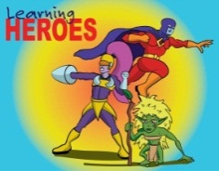
Learning Heroes – We have two groups of learning heroes to report in this newsletter. On 12th May, in our Achievement Assembly, the following children were awarded as learning heroes
Yr 1; Mia & Logan
Yr 2; Jude & Charlie
Yr 5; Callum & Louie
Then on 19th May, the following were also awarded as learning heroes;
Yr 1; Miley & Ava
Yr 3; Iga & Skye
Yr 4; Joesey & Lily
Well done to all our children for showing their use of ‘building learning power’.

BLP Focus – Making Links (Linked to Resourcefulness) This means you look for connections between events and experiences.
Over the next two weeks can you make links when carrying out a task at home by:
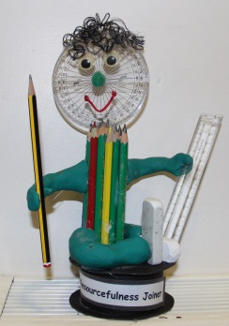
- Creating a mind map together. Pick a number, picture, idea… Place it in the middle of a page and add anything around it that links
- Comparing trips and activities to each other. What was the same? Different?
- Creating a family tree
Let us know what you have done as a family, you could blog about it (don't forget to tag it BLP) or send us a picture!

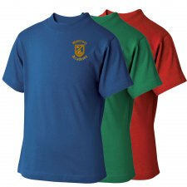
Sports Day – Just a reminder that children need to wear a PE t-shirt that corresponds to the colour of their house (More is Green, Brunel is Blue, Fry is Yellow, Red is Cabot).

Thank you to everyone who purchased an ice lolly or ice cream on Friday 12th May. We raised a fantastic £77.07 for the East African Crisis Appeal.

Can we please remind parents and children that bikes and scooters are not to be ridden in the car park or anywhere on site unless part of free range play. When they are ridden, children need to be wearing a helmet please. Also, if children are on site before 8.45am, they need to attend breakfast club.

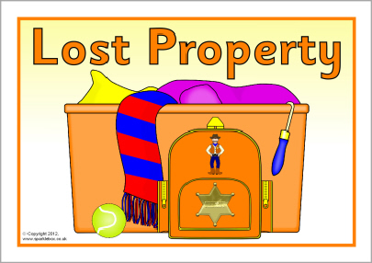
Lost Property – We have an awful lot of lost property that has accumulated again over the past two terms. It really is important that children’s uniform, coats and PE kits are labelled. Please do come and take a look if your child has recently mislaid something.

Arts Evening – Thank you to all those parents, carers and children who attended our Arts Evening on the 25th. I think you’ll agree that the art displays created by the children for this event were absolutely fantastic. I hope the adults found the evening both informative and entertaining.

Inhalers – We have several inhalers kept in school that are currently out of date. When sending in a replacement inhaler, please ensure it comes in its original box, which clearly details the prescription label so we know who the inhaler belongs to. Thank you.

Congratulations to Emily B in Year 6 who was recently awarded a distinction in her Grade 1 saxophone exam and to Isobel in Year 4 who was also awarded a distinction for her initial piano exam. Well done to both girls.

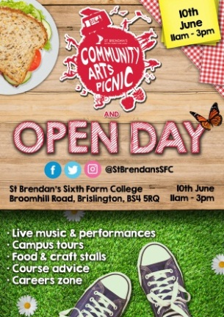
Gymnastics news - On 18th May the Waycroft Y3-4 gymnastics squad competed in the Bristol competition held at the Hartcliffe gym centre. Then on 25th May, it was the turn for the Y5-6 squad. All the children competed brilliantly and were a credit to the school. Waycroft 'Panthers' team won the gold medal on 18th May and Waycroft ‘Jaguars’ & ‘Panthers’ both won gold medals on 25th May with many individuals being placed across both days.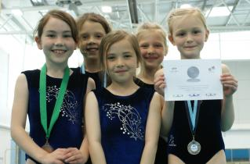

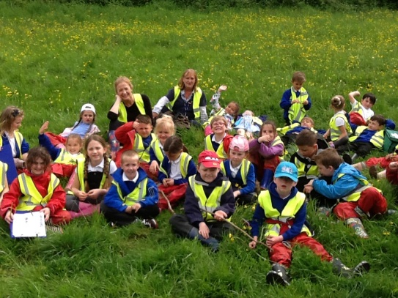
Outdoor Classroom Day - Key Stage 1 were pleased to see sunshine at last for Outdoor Classroom Day on Thursday 18th May! Year 1 explored the fields in search for dandelions and daisies and Year 2 walked to the Open Space in Stockwood to find lots of minibeasts.

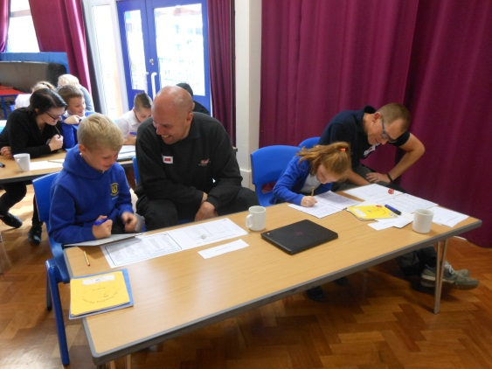
Year 4 Parent Workshops - Thank you so much to all the adults who attended on Monday 22nd May, it was a fantastic turnout. We looked at 3 different aspects of SPAG and used these within a descriptive blog post about our demon visitor! Adults and children worked alongside each other sharing their knowledge and skills - a great experience for all.

St. Brendan’s Sixth Form College – Community Arts Picnic and Open Day – 10th June, 11am – 3pm. Come along for live music and performances, campus tours, food & craft stall, course advice and careers zone.

Mufti-day – Friday 9th June. Children can wear something green, something home-made or something recycled. It doesn’t have to be elaborate and certainly not cost the earth. This is to fit with the Eco theme of this year’s Summer Fayre. In return we ask that all children in non-uniform bring in a bottle donation. Bottles can be alcoholic, non-alcoholic, food items or cosmetics. Please can donations be unopened & in date!

Half Term – Finally, I hope all our children and their families have a wonderful half term break. We look forward to seeing the children back on Tuesday 6th June, ready for the start of our final term this academic year.

Yours sincerely
Lisa Craig
Head of School

