Dear Mothers, Fathers and Carers

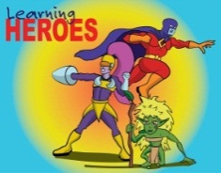
Learning Heroes – We have two groups of learning heroes to report in this newsletter. On 26th May, in our Achievement Assembly, the following children were awarded as learning heroes
Yr 3; Beau & Ben L
Yr 4; Archie & Jack
Yr 5; Paige & Andy L
Yr 6; Ava, Madeline & Libby D
Then on 9th June, the following were also awarded as learning heroes;
Yr 1; Lucas & Emily
Yr 2; Thomas & Abi
Yr 5; Alice & Sienna
Yr 6; Laura, Chloe G & Emily M
Well done to all our children for showing their use of ‘building learning power’.

Final call for Sainsburys vouchers as these will be sent off at the end of June. Any final stray vouchers sat in purses & wallets to be handed in by Friday 23rd June please.

Don’t forget to come along to our school Summer Fayre organised by the Friends of Waycroft. It is on Saturday 17th June from 12 noon to 3.00pm. There will the usual popular stalls including face painting, tin can alley, lucky dip, a bouncy castle as well as a BBQ, cake stall and other refreshments. Bring along your purses & wallets for an afternoon of family fun!

KS2 Sports Day will be held on the morning of Thursday 29th June and KS1 on Friday 30th June. Parents are welcome from 9.20 am.

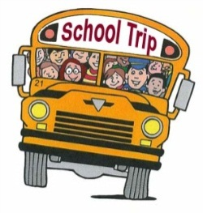
Upcoming Trips; Year 1 will be visiting Berkeley Castle on Wednesday 21st June. Year 6 are visiting Mendip Outdoor Pursuits in Churchill on 4th July. Reception are off to Folly Farm on 12th July and finally, our Nursery children will be venturing to Court Farm next month too. If you are yet to give consent or pay your voluntary contributions for any of these trips, please do so asap; especially the Berkeley Castle trip which is scheduled this month.

Induction Evening for Y1 – Y6 is on Thursday 13th July. One meeting will be held at 6.00pm then repeated at 6.45pm to give parents a choice of times and to attend more than one year group meeting if necessary. Families will meet the teachers who will be in each year group next year and hear about routines and expectations. Children are welcome to attend if you wish.

Safety warning - Musical-ly and Live-ly
Please be aware that there have been some child protection and safety concerns about these apps in the press recently. Adults have been contacting children through the app in an inappropriate manner so it is important that families are monitoring children's use of these apps and the internet in general, and that children know what to do if someone sends them a message particularly if it makes them feel uncomfortable.

Free School Meals – If your child is currently in Year 2 and will be moving to Year 3 in September, don’t forget to apply for Free School Meals if you think you meet the criteria. You can apply online via https://efsm.bristol.gov.uk. Universal Infant Free School Meals ends for Year 2 children at the end of Term 6.

Staffing - Goodbye to Miss Pickford who will be leaving us at the end of the year to continue her studies at University from September. Mr Empson starts with us on 19th June as our new Sports Apprentice and will be working alongside Miss Pickford before she leaves at the end of July. Mrs Clarke, one of our Teaching Assistants who has been at Waycroft for over 25 years, also leaves us this summer. Mrs Holmes, one of our playmakers, leaves us at the end of this month to continue with her other career. And of course, Mrs Sage is retiring at the end of this academic year too. All will be sadly missed but we wish them well with their new adventures.
New staff will be announced later this term once our recruitment process has been finalised towards the end of this month. 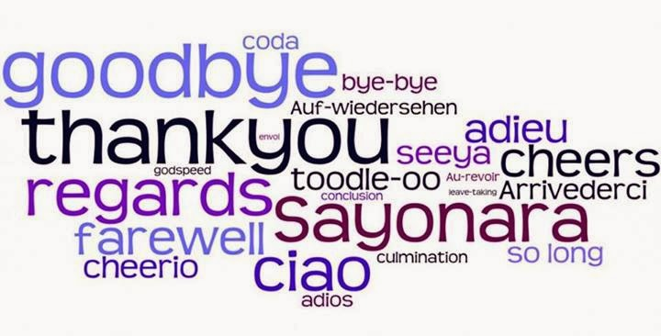

End of Year Reports – These will go home with the children on Tuesday 18th July.

Free Range Play Picnic – Monday 17th July between 3.20pm and 5pm. Please come and join us for our Free Range Play afternoon. Come and try out some our free range play activities, some which have been newly designed and created by the children. Feel free to bring a picnic. Simply collect your child/ren at the end of the school day in the normal way, then stay as a family. No unaccompanied children will be allowed to stay on the school site.

P.E. Kits – Can we please remind children and parents that P.E. kits should be kept in school and only taken home at the end of each term to be washed. Also, we must insist that children wear suitable footwear for their P.E. lessons. They are NOT to wear their school shoes for P.E. Thank you for your co-operation.

Alive N Kicking is a healthy lifestyles programme for children aged 5-11 years; Alive N Kicking are working
with Bristol City Council to provide families with practical advice to help improve your children’s diet and make healthier choices for the whole family. The programme is FREE for families to attend with weekly sessions on healthy eating, physical activity and support from the Alive N Kicking Team to ensure you and your family have a healthy summer!
Alive N Kicking are running a programme at Hengrove Leisure Centre starting 4th July @4pm; if you are
interested in attending the programme with your children or would like to find out more please contact
Hayley at Alive N Kicking on 0117 942 2602 or email bristol@ank.uk.com

Green Flag award - Last term, the Green Team were visited by an assessor from Eco Schools. The Green Team, as well as the whole school, have worked hard to improve the school environment. They have increased recycling, improved the school grounds through planting and reduced litter. In addition, the children have changed the way they travel to school to a more environmentally friendly way.
The visitor, Clare, was very impressed with the school's progress over the last 12 months. She commented on the passion the children showed for being green. The Green Team and all the children at Waycroft are extremely excited to be awarded the Green Flag by Eco Schools. We are all very proud of their efforts. Look out for the green flag which will be flying soon! 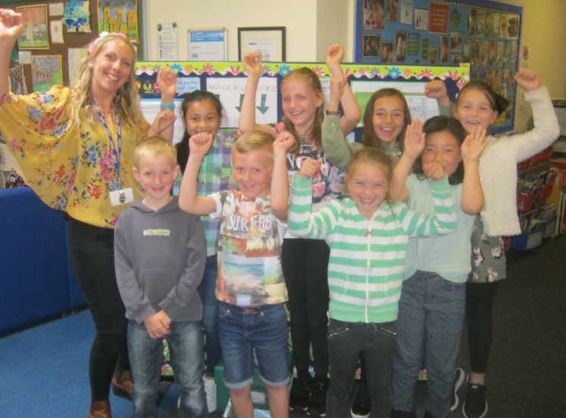
Yours sincerely
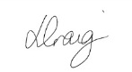
Lisa Craig
Head of School

