Dear Mothers, Fathers and Carers

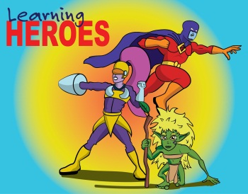
Learning Heroes – Each week in our achievement assemblies we will be celebrating children’s use of BLP (Building Learning Power). A child from each class will be nominated as a ‘learning hero’ (when it is not their focus assembly). For the assembly that took place on 4th November, the following children were nominated as our Learning Heroes; Erin, Madison B and Kaitlyn in Year 6, Jayden and Evangeline in Year 5, Alex K and Megan in Year 2 and finally Oliver W and Coby in Year 1. Congratulations to all our learning heroes.

We have recently published our new child protection policy which is available to view/download from our website: http://www.waycroftacademy.com/child-protection-policy

Clubs – Please can parents and carers check the finish time of their child’s club/s. We have some children waiting to be collected well past the time their club has finished. The very latest any child should be collected is 5.30pm from High Five. However, we still have some children waiting after this time. Can you also please inform the office if your child is not going to be attending their club, so they can make a note on the relevant register. Thank you for your cooperation.

Thank you to all the parents, staff and children who purchased one of our special knitted poppies. Mrs Nicholls and Miss Archer raised an incredible £500.16 for the Poppy Appeal.

British Legion Visit - Our Year 2 children were exceptionally well behaved and attentive at the British Legion poppy day service on November 11th.

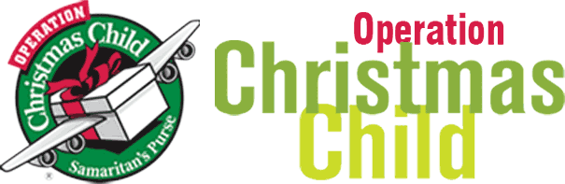
We had a total of 85 shoeboxes donated for the Samaritan’s Purse ‘Operation Christmas Child’ campaign this year. To everyone that made a box, or donated items, we are extremely grateful. Your generosity is truly appreciated and will brighten the lives of children around the world this Christmas.

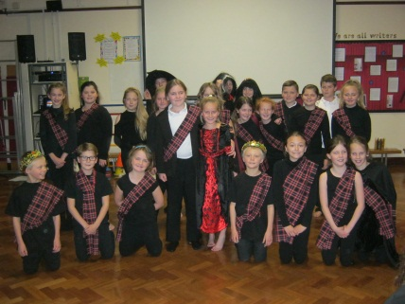
On Monday 7th November children from year 5 and 6 performed Macbeth at the Egg Theatre, Bath to a packed crowd. The children have been rehearsing exceptionally hard over the last few months with Miss Leach and Miss Dennis and the results were clear for all to see. What a Shakespearean treat everyone had!

Christmas Lunches: School Christmas lunch arrangements are as follows:
Reception & KS1 – Christmas lunch will be on Tuesday 13th December and KS2 will have a buffet lunch.
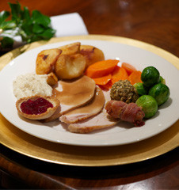
KS2 - Christmas lunch will be on Wednesday 14th December and Reception and KS1 will have a buffet lunch. We will shortly be sending home an electronic form via parentmail for parents to complete, indicating if they would like their child to have a Christmas lunch and /or buffet options on their chosen dates. The form will also indicate if your child would like the vegetarian option, or a packed lunch. Even if you plan on giving your child a packed lunch for both of these days, can you please still complete the form to indicate this. We will need a completed form for every child from Rec- Yr 6. KS2 parents will also need to log into parentpay and pay for the relevant number of meals in advance. Thank you.

Christmas Concerts
Our Christmas concerts are coming soon. Year 1 to Year 6 perform these concerts and they will be held, as last year, in Christ the Servant Church. This year we have varying start times, so please do read the following carefully;
Y1/2 Monday 12th December @ 2pm
Y5/6 Thursday 15th December @ 10am
Y3/4 Thursday 15th December @ 2pm
Please note that the children work very hard on practising their lines for the Christmas story and rehearsing their carols. If you are going to take younger children, we do ask that you are respectful of those children performing and step outside with any children who become restless.

Nativity Plays – Performed by our Reception classes
Monday 5th December– Nativity Dress Rehearsal Babies and toddlers are welcome to accompany their parents to our dress rehearsal. 9.15am in the school hall.
Thursday 8th & Friday 9th December, both at 9.15am in the school hall. No babies or toddlers on these two occasions please.
Photography at Christmas Events
Please note that photographs can only be taken at the end of our Carol Concerts and Reception Nativity performances. This is because we have a number of children whose parents/carers have requested that photographs are not taken. There will be a photo opportunity at the end of each performance.

Play to Learn – We currently have three spaces in our Play to Learn club; two on a Monday afternoon and one on a Wednesday afternoon. If you have a child who is two years old and you would like to join Play to Learn, please speak to a member of the office. These sessions are ‘stay and play’ afternoons for local mums to give their child the opportunity to make friends and play cooperatively, learning to share their toys and games with others. Play to Learn is a self-supporting group. Fees go towards providing a paid playleader, consumables, such as paper, paint etc. Each session is 1.30pm – 3pm, charged at £3.

Super Science Giveaway – There will be 100 tokens printed in the Bristol Post this Friday, 18th November. Please pop them in the box in reception on Monday!

Congratulations to Andy L in Year 5 who won one of the Young Film Reviewers of the week on the website for Film club. The review was for the anime film Princess Mononoke. You can read his review here: https://www.filmclub.org/film/3123/princess-mononoke. It’s an absolutely fantastic review, so we are thrilled that the panel at Film Club have chosen him to receive a prize. Well done Andy!

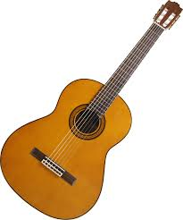
Guitar Lessons – There are currently some spaces with our guitar teacher, Mr Barlow on a Thursday afternoon. If your child is interested in learning to play the guitar, please register your interest with the office. Lessons are charged at £5 per week and payment must be made in advance. One of our music teachers will be in contact with any interested parents.

Mobile phones – Just a reminder to our parents, carers and volunteers that we do not allow the use of mobile phones on the school site. Thank you for your understanding and co-operation.

Eco Club worked hard last term getting ready to introduce recycling into school. We are encouraging more recycling including food recycling and plastic recycling. We now have food bins in each classroom and we are washing yoghurt pots at lunchtimes and reusing these pots for art and DT.
We are currently selecting children for our Eco team (separate to Eco Club which resumes in January) where children will be working towards ensuring our school is becoming increasingly green by meeting once a term to discuss ideas. Please remind children to hand in their applications. We look forward to working with these children to introduce more recycling, improving our outdoor spaces and decreasing the amount of litter in and around the school.

Yours sincerely
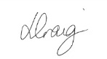
Lisa Craig
Head of School

