Dear Mothers, Fathers and Carers

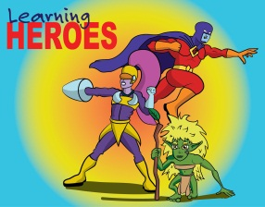
Learning Heroes – We have two groups of learning heroes to report in this newsletter. On 27th January, in our Achievement Assembly, the following children were awarded as learning heroes
Yr 1; Chase & Ryley.
Yr 2; Zach C & Aliviya-Anais.
Yr 3; Leelanie & Sophie.
Yr 4; Isobel & Phoebe J.
Then on 3rd February, the following were also awarded as learning heroes;
Yr 3: Melody & Libby. Yr 4: Thomas & Gracie.
Yr 5: Tamsin & Megan. Yr 6: Cameron C & Ashten. Well done to all our children for showing their use of ‘building learning power’.

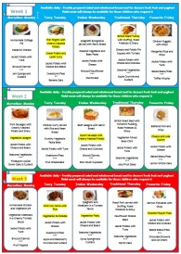
Menu Survey - Thank you to those parents that completed the menu survey during our open day. We will be working on our summer menu shortly and will be taking all of your ideas into consideration. Prizes were sent out last week for those with our favourite suggestions.

Can we please remind parents that nuts are NOT to be brought in for packed lunches. We have children in school with nut allergies. Thank you for your understanding.

Welcome to Mrs Simmons who will be joining our lunch time team of playmakers after the half term break. Mrs Simmons replaces Ms Mohide who left us this term to move onto pastures new. We will also be welcoming Mrs Belsten who will be joining the nursery team as a playmaker on a part time basis between terms 4 & 6.

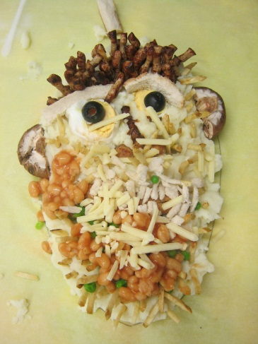
Roald Dahl Event - After listening to extracts from ‘The Twits’ and taking inspiration from Roald Dahl’s Revolting Recipes, Year 3 and 4 children were invited to create their own ‘Mr Twit’. Teams of four used the recipe and instructions to produce their own supper - Mr. Twit. This was washed down with Mr. Twit's 'beer' - which, to the children's horror contained Mrs. Twit's glass eye! To judge each face, we were visited by the real, very rude and grumpy (yet hilarious) Mr. Twit. The 'Clucking Chickens' team were the winners. Well done boys.

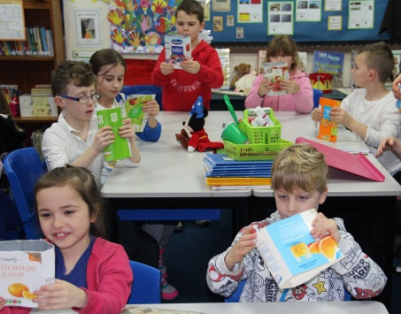
Eco News - On Tuesday 31st January, children from Key Stage One, Year 4 and Eco Club were lucky enough to take part in upcycling workshops. They learnt all about the benefits of recycling materials and used their creative skills to turn rubbish into upcycled objects. The children were very excited to show off their notebooks, bags and purses.

Thank you to Co-Op on Hollway Road – They very kindly donated the ingredients for our Ace It Cookery Club this month, allowing them to bake carrot, beetroot and banana muffins.

Cash 4 Coins – Thank you to everyone who donated their foreign coins last year. The Friends of Waycroft have had the currency converted and we raised £71.82.

Parents’ Evening – The appointment sheets are now in the foyer. Parents’ evening will take place on Tuesday 21st & Wednesday 22nd February from 3.30pm. If you are unable to come in and book your appointment, please telephone the school office.

Clubs – Some clubs will be cancelled during the above parents’ evenings. Gym club will only be open to KS1 children and will be held in the new hall. There will be no Football, Colouring, Film Club, Stages, Netball or Recorder Club. High Five WILL go ahead as usual as well as Ace It. Just a reminder to Eco Club children that this club only runs in Terms 1, 3 and 5, so will not be taking place after the February half term. Can we also ask parents that if their child is not going to attend for whatever reason, please can you inform the office in advance. Thank you.

Camp payments: Thank you to all those parents who have paid their deposits for Year 2, 4 & 6 Camps. For those that are yet to pay, here is a reminder of the deadline dates:
Year 2 (Barton Camp) - £10 deposit by 24th February
Year 4 (Hooke Court) - £20 deposit by 3rd March
Year 6 (Simonsbath) - £50 deposit by 17th February

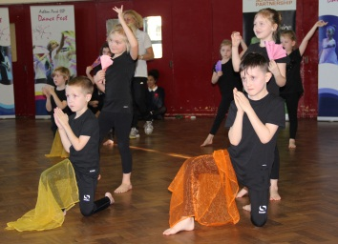
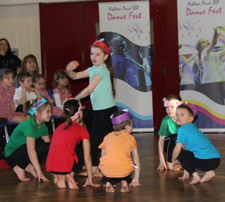
KS1 Dance Festival - Year 2 had a wonderful time at the Key Stage One Dance Festival hosted by the Ashton Park School Sports Partnership. Matthew class performed a very colourful Carnival Dance with colourful hats. Mayflower class stomped through to the end with a Spanish themed dance using brightly coloured scarves and fans. However, Waycroft Academy wasn’t the only school that took part. This meant that we were able to watch some other schools perform their dances too!
Parking – Can we ask parents and carers not to park in front of residents’ driveways. Thank you for your consideration.

Safer Internet Information - Following Safer Internet day on Tuesday 7th February the BBC have released an informative video offering guidance for sharing children's images online. Please visit: http://www.bbc.co.uk/guides/z3b6y4j

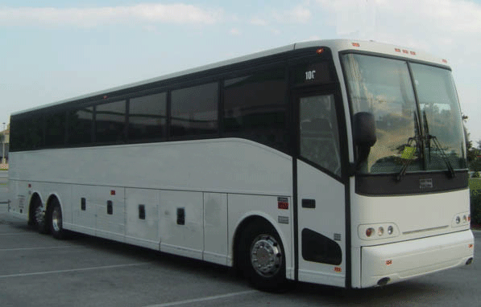
Trip money: It is due to our parents and carers consistently paying the full voluntary contribution that our varied programme of school trips can go ahead; thank you for this. Can I please remind you that we only ever charge exactly what the trip will cost for your child, therefore, in line with the charging policy, visits can be cancelled if sufficient money is not collected.

World Book Day – Just a reminder that children can dress up as their favourite book character on Thursday 2nd March. There are lots of ideas regarding costumes available online via the world book day website.

Thank you to the Friends of Waycroft for organising a very successful film night. The movie Zootropolis was a huge hit with the children. Everybody enjoyed their popcorn and drink whilst relaxing in their pyjamas!

Finally, we hope you all have a very restful half term break and we look forward to seeing the children again on Monday 20th February when we return for Term 4.
Yours sincerely
Lisa Craig
Head of School

