Dear Mothers, Fathers and Carers

Congratulations to the KS1 Gymnastics team: Felicity, Olivia D, Olivia C, Blyss, Bethany and Xanthe who came second in the recent schools' competition. They all performed beautifully and represented the school with pride. The children had the opportunity to try out lots of new gymnastics skills on different apparatus as well as being judged on their floor routines and their vaults. They are all very pleased with their medals; well done to them all.

Sports News - Waycroft entered three Year 5 teams into the Quick Sticks hockey tournament at Merchants’ Academy earlier this month. All teams collaborated well and persevered; it was fantastic to see how the children progressed during the day. Congratulations to one team who took bronze medals and move through to county level in term 5.

Polite Reminder – Please can we remind parents that unless children are attending breakfast club, they should not be on the school site until 8.45am. You are responsible for your child until this time and it is not acceptable for children to be using the car park and grassed area as a playground. They have a 10 minute supervised time frame to arrive at school and this is for their safety. We also need to ask that parents don’t allow their children to knock on windows and doors of the classrooms at the end of the day whilst waiting for classes to be dismissed. It is very distracting, especially for the younger year groups. Thank you for your understanding and cooperation.

At the beginning of March the school had its Challenge Partner review when teaching and learning and school systems were scrutinised by three senior leaders from other schools in England and a registered OFSTED inspector. The team verified that Waycroft remains OUTSTANDING. The reasons for this are identified in the written report, a copy of which was emailed to parents earlier this week. Alternatively, please view the report on our website.

Musical.ly – This very popular app used by children of all ages, has been in the local news lately following reports of online grooming involving graphic messages with a pupil in a Bristol school.
We urge parents to discuss the safety rules around using apps such as musical.ly and YouTube etc. with your children and make sure they are clear of the action that needs to be taken if they are concerned or unsure about something.

Mother’s Day Lunches – It has been wonderful to see so many mothers, grandmothers and carers in school having lunch with their child/ren. We hope all those that attended enjoyed their special dinner date.

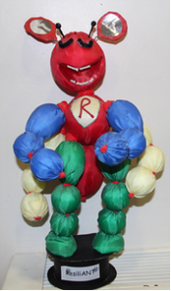
BLP focus - Managing distractions
This means you are able to recognise possible distractions and ensure you stay on task. You can create your own best environment for learning. Over the next two weeks can you manage your distractions when carrying out a task at home by:
-Timing how long it takes you to write out your 9 times table. The next day time yourself again, however play music in the background or get someone to do a funny dance to try to distract you. Do you still get the same time?
- Singing your favourite song whilst someone else sings theirs. Can you stay on track?
-Creating a family distraction list, before starting an activity together, to ensure everyone stays on task.
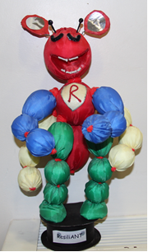
Let us know what you have done as a family, you could blog about it (don't forget to tag it BLP) or send us a picture!

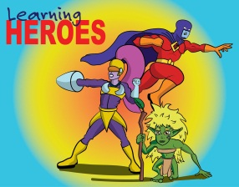
Learning Heroes – On 24th March, in our Achievement Assembly, the following children were awarded as learning heroes
Yr 3; Soul & Lydia
Yr 4; Janey & Miley
Yr 5; Neave & Hollie
Yr 6; Chelsea, Bailey & Raymond
Well done to all our children for showing their use of ‘building learning power’.

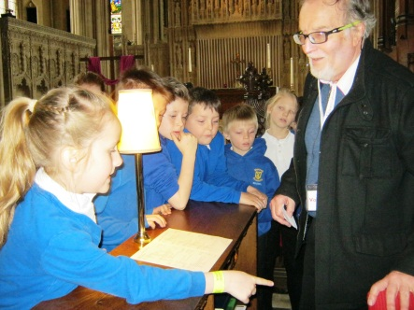
Year 5 had a fantastic experience visiting both a Mosque in Easton and Bristol Cathedral during their recent R.E. trip. The children were impeccably behaved and put some excellent questions to the guides. We had the privilege of exploring both buildings and discovering the different values and traditions held within them. It was wonderful for the children to find out the contrasting features of both buildings enhancing their R.E. learning for this term.

Clubs – Earlier this week, our clubs list along with an accompanying letter and reply slip was emailed out to parents via ParentMail. Children that wish to sign up to a club can either print a reply slip at home and bring it in, or they can request one from the school office. Each class teacher has also been given paper copies to pass onto any interested children. The deadline for returning these slips is Wednesday 5th April. Please can we reiterate that the only clubs you can return slips for starting next term are; Book Club, Tag Rugby, Athletics, Singing Club, Maypole Dance Club and KS1 Dance Club. The KS2 gymnasts will be continuing with gym club next week, as well the first week of Term 5 in order to prepare for their up-coming competition.

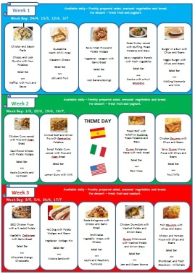
New Menu – We will have a new spring/summer menu available from Term 5. We are introducing a delicious new salad bar as well as some other tasty treats. This menu will be emailed out to parents before the end of Term 4. It will also be published on our website, under the parents tab.

Red Nose Day - We are delighted to say that an impressive £388.87 was raised for Comic Relief last Friday. The children looked fantastic in their red outfits. Thank you to everyone who donated to this wonderful charity. 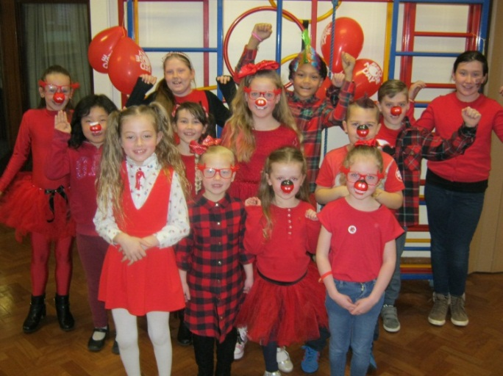

BTR – Thank you to everyone in the local community who donated to the Bristol Textile Recycling collection on Monday. We raised £80.40 for our Eco Team.

Yours sincerely
Lisa Craig
Head of School

