Dear Mothers, Fathers and Carers

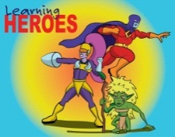
Learning Heroes – We have an impressive three groups of learning heroes to report in this newsletter. On 16th June, in our Achievement Assembly, the following children were awarded as learning heroes
Yr 1; Madison & Jack M
Yr 2; Finley
Yr 3; Ellis & Yihan
Yr 4; Riley & Dylan
Then on 23rd June, the following were also awarded as learning heroes;
Yr 3; Matthew & Ayaan
Yr 4; Jacob & Amy H
Yr 5; Imogen & Grace M
Yr 6; Charlie, Libby G & Toni
Finally, on 30th June the following children also received the learning heroes accolade;
Yr 5; Rosie & Hadyn
Yr 6; Gracey-Jane, Isabelle & Thuva
Well done to all our children for showing their use of ‘building learning power’.

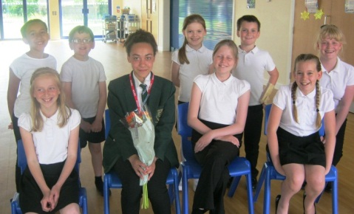
E-Safety News - On the 14th June, Adele B (Year 7) returned to Waycroft to explain a bit about E-Safety in secondary school. Year six were lucky enough to learn about the digital differences between primary and secondary school. We (the E-Safety ambassadors) interviewed her using questions we had created. Adele's top tips;
1. Wait until you are the correct age to download apps.
2. Don’t respond to someone in the middle of an argument – you may regret what you write later.
3. Think carefully before posting - you may regret having things online in a few years’ time.
4. Ignore scams.
5. Don’t answer ‘no caller ID’ on Facetime.
Join Apple Camp, a free three-day programme for kids aged 8 to 12. They’ll broaden their creative horizons by making films, composing musical stories, coding games and robots, and more using Apple products. Further information can be found at: https:// concierge.apple.com/camp/choosestore/en_GB

Information for Parents re: Snapchat App - When using snapchat, there is a function that is automatically enabled that can track your location unless you disable it. This means that anyone that you are linked to on snapchat can locate exactly where you are, which building you are in and the exact whereabouts within the building. If you pinch the screen, your location will be shown. To disable this you click on the settings button (the cog) whilst on this screen, tick the option 'ghost mode'. This will then be disabled. Please be safe when using social media.

Free Range Play Picnic – Just a reminder that this picnic is taking place on Monday 17th July between 3.20pm and 5pm. Come and try out some of our Free Range Play activities, some which have been newly designed and created by the children. Feel free to bring a picnic. Simply collect your child/ren at the end of the school day in the normal way, then stay as a family. No unaccompanied children will be allowed to stay on the school site.

WELL DONE! – to the Friends of Waycroft for organising yet another successful summer fayre. The sun was shining on the day and we had a fantastic turnout. We are delighted to announce that the Friends raised an incredible £3,000 profit. This wouldn’t have been possible without the support of everyone in the local community who either donated an item or attended the fayre itself.
Race for Life – Thank you to everyone who took part in this year’s event. Just a reminder that all sponsorship money needs to be handed into the office by Wednesday 12th July. Thank you to Mrs Kelson for organising another successful morning and to all those in the local community who took part or helped in any way. 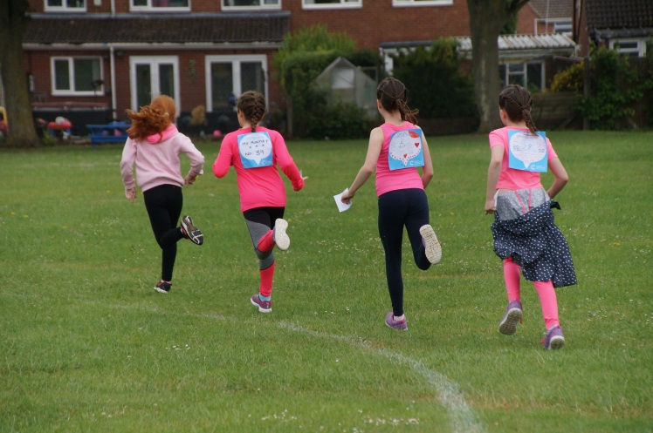

Sports Day – Despite the rain last week, it still managed to stay dry for both KS1 & KS2 Sports Days. A huge well done to everyone who took part. There was great sportsmanship shown across both mornings which was lovely to see.
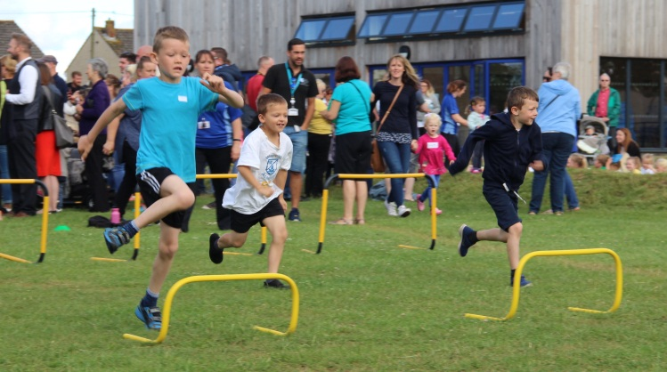

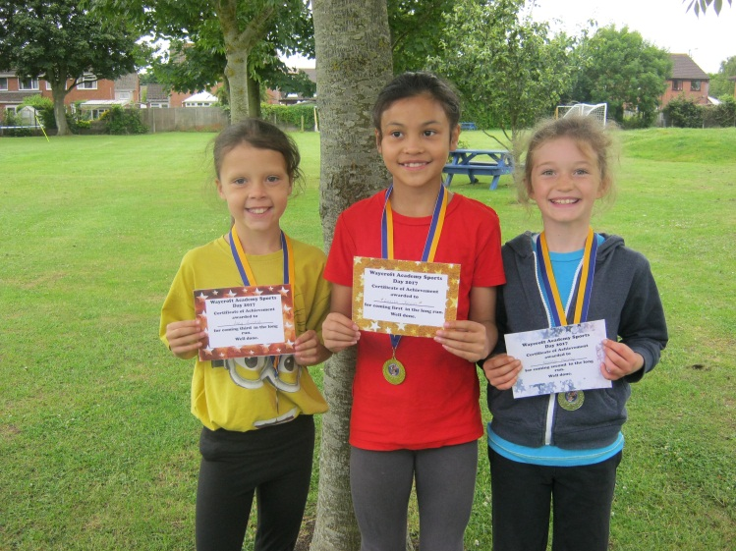

Reminder – Following the letter sent home last Friday, please add the following date to your diaries; INSET day Monday 4th September 2017.
Staff changes for September - In order to share the expertise and experience of those teaching staff within the Multi Academy Trust, Mr Jordan will be seconded to Woodlands Academy from September and Mrs Howells seconded to Wicklea Academy. We have a number of new members of staff joining us, as outlined in our last newsletter. Don’t forget you can meet your child’s new class teacher when we have our induction evening for Yr 1-6 children on 13th July. Both Mr Jordan and Mrs Howells will still be under the Waycroft umbrella and we will still have close contact with them as they continue their teaching careers in Woodlands and Wicklea for the next academic year.

Waycroft email accounts – Children have been issued with Waycroft email accounts so they can access google drive which enables them to work collaboratively with their peers, share documents with teachers and acts as an online portfolio of their work. Some classes use the email account to cover the computing curriculum which includes a unit on sending and receiving emails. The email addresses are set so that they can only be accessed when children are currently completing that unit, or the teacher has requested for it to be active. These email addresses are only to be used for Waycroft related purposes. If you have questions relating to this, please feel free to contact Mrs Horwood, our ICT subject leader.

Book Amnesty - Please can you all look…on the shelf, under the bed, under the sofa, behind the wardrobe and anywhere else that Waycroft Reading Books may be hiding? Please return ALL lost books to the library by Thursday 13th July (Reading or library book). Then we can get them back to their baskets ready for next year. Do not be embarrassed if you have had them a long time- just PLEASE return them to school!

Simonsbath Camp – The office will be issuing the medical forms for this camp to the children this week. Can all parents and carers please ensure they are completed and returned to the office before we break up on 21st July. Thank you.

Yours sincerely
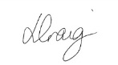
Lisa Craig
Head of School

