Dear Mothers, Fathers and Carers

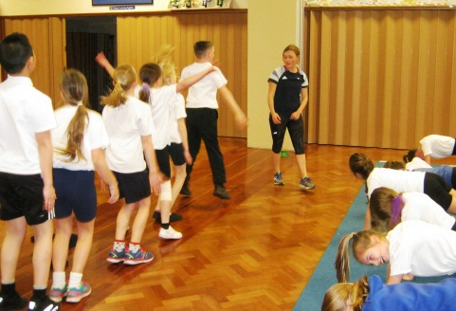
Katrina Hart Sports for Schools Visit – At the end of last term, years 3, 5 and 6 were lucky enough to participate in a sponsored fitness circuit with Olympian Sprinter Katrina Hart. The children raised an incredible £533.50 which will go towards both purchasing new P.E equipment for our school and helping to support GB athletes who might otherwise struggle financially to compete for their country. Thank you to all those adults who sponsored one of our children.

Year 1 Swimming; Unfortunately Hengrove swimming pool have cancelled our swimming lessons on 5th April due to the pool being closed for a competition. The children will now be swimming on 17th May to make up for the lost lesson.

World Book Day – The children looked absolutely fantastic, dressed as their favourite book characters on Thursday 2nd March. They were also excited to learn in assembly that Huw Powell has agreed to be our Patron of Reading here at Waycroft Academy. This was relayed by a very special message which was recorded by Huw Powell himself and shown to the children in assembly. 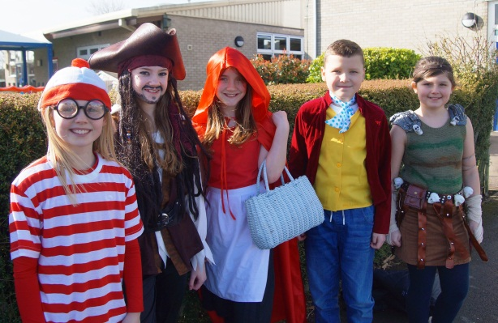

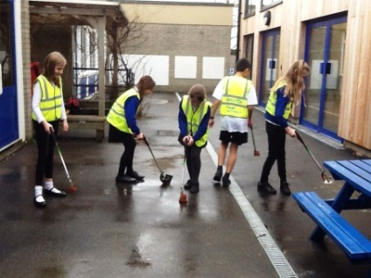
Litter Week - Waycroft has been learning all about the effects of dropping litter. During one of our assemblies, we discussed the different ways litter can affect nature. Sadly, dropping litter can be very harmful to our animals. Many children volunteered to take part in litter picking at lunchtimes and break times. Here are some pictures of our litter pickers in action:

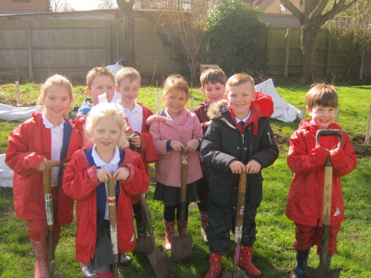
Green Team News - We were very lucky to receive some volunteers earlier this month who helped create our Eco Garden. The Conservation Volunteers worked very hard all day digging and raking to plant hedges to create a special den for us to learn all about habitats during our Science topics. Western Power kindly provided funding for this to go ahead. Some of our own Green Team and Science enthusiasts also went out to help with all the hard work.

Netball – Some of our year 5 & 6 children represented Waycroft at a netball festival hosted by Merchants’ Academy last week. We had two teams, both of whom played extremely well. The children were a credit to Waycroft, playing collaboratively with a fantastic team spirit. They won or drew every game they played. Miss Fish and Mrs Horwood were very proud of their sportsmanship. Well done!

During assembly on 8th March, we had a visitor from Bristol Textile Recyclers who talked to us about recycling unwanted clothes. Over the next two weeks, our job is to bring in unwanted clothing which will be collected on Monday 27th March. Every bag we collect will raise money that will go towards making our grounds more environmentally friendly, for example we will be able to buy plants and seeds to be grown in the school grounds. Please start searching through your wardrobes. Get recycling! Please do not bring your bags in before 27th March.

The BLP Muscle Focus this week is: Noticing (linked to Resilience) -
This means you are able to spot possible patterns and details and notice how things work, are made or how they behave.
Over the next two weeks can you take more notice when carrying out a task at home by:
-Hiding an item that is always in a room, can someone else spot what is missing?
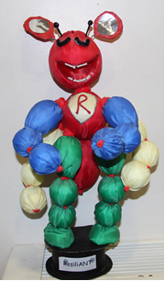
-Having a tray of 15 items and letting someone look at them for 10 seconds. Cover it, take one item away. Can they guess what is missing?
-Looking at a bike, can you work out how the wheels move from someone pedalling?
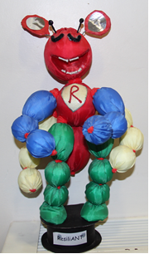
Let us know what you have done as a family, you could blog about it (don't forget to tag it BLP) or send us a picture!

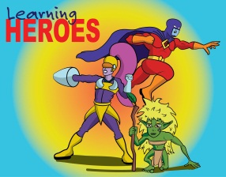
Learning Heroes – On 10th March, in our Achievement Assembly, the following children were awarded as learning heroes
Yr 1; Renae and Louis
Yr 2; Felicity and Jennifer
Yr 3; Harvey and Connie
Yr 4; Ruby G and Joe B
Well done to all our children for showing their use of ‘building learning power’.

INSET days for 2017/18 –
Monday 30th October 2017
Friday 15th December 2017
Friday 9th February 2018
Monday 4th June 2018
Friday 13th July 2018

BLP Focus: Absorption – In our last newsletter, we asked the children to think about absorption. This involves ‘getting lost in your learning’. One of the suggestions given was to write a poem together as a family. Jena in Year 5 has written a beautiful poem called ‘Seasons of the Year’. We think this is a fantastic example of the BLP muscle absorption! 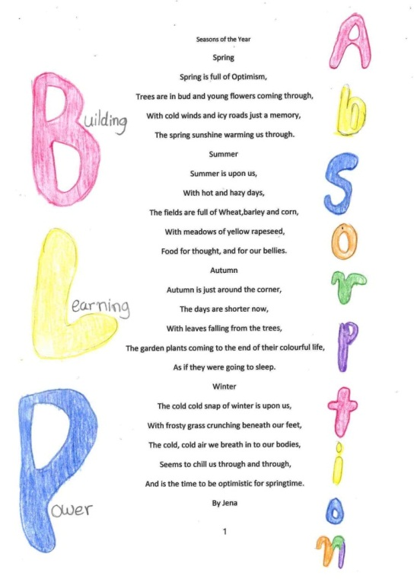

Do you have any family DVDs that you no longer need? The school Library would be grateful for them. We would particularly like any films that are derived from well-known children's books. We can only accept U or PG rated films. Thank you.

30 hours Nursery Funding - The Government is introducing 30 free hours of childcare for under 5s to eligible families from September 2017. The application process for this will be completed online by parents, however you need a 'Government Gateway' ID to do this. If you are interested in the 30 free hours then please apply using the following website link: http://www.gateway.gov.uk/
There is also an online calculator that helps you work out how much you can claim. Visit this website for more information: https://www.tax.service.gov.uk/childcare-calculator/children/number.

Yours sincerely
Lisa Craig
Head of School

