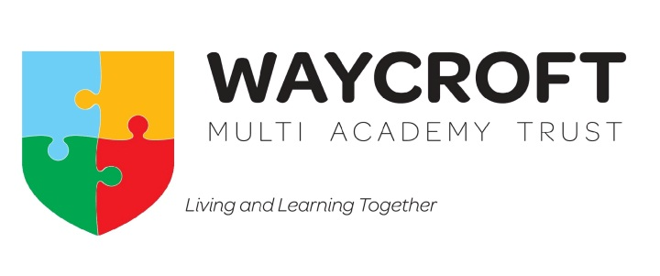

School uniform policy 2022

Signed (chair):  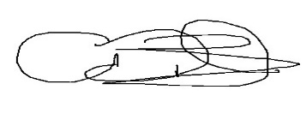 | Name:  Andrew Bowden | Date:  13th September 2022
Signed (Executive Head):  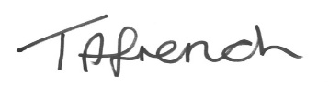 | Name:  Tracy French | Date:  13th September 2022
Ratified by:  Board of Trustees on 13th September 2022 |  | Next Review:  September 2024
New policy

Contents
1. Aims 2
2. Our school’s legal duties under the Equality Act 2010 2
3. Limiting the cost of school uniform 2
4. Expectations for school uniform 3
5. Expectations for our school community 3
6. Monitoring arrangements 4
7. Links to other policies 4
1. Aims
This policy aims to:
- Set out our approach to requiring a uniform that is of reasonable cost and offers the best value for money for parents and carers
- Explain how we will avoid discrimination in line with our legal duties under the Equality Act 2010
- Clarify our expectations for school uniform

2. Our school’s legal duties under the Equality Act 2010
The Equality Act 2010 prohibits discrimination against an individual based on the protected characteristics, which include sex, race, religion or belief, and gender reassignment.
To avoid discrimination, our school will:
- Avoid listing uniform items based on sex, to give all pupils the opportunity to wear the uniform they feel most comfortable in or that most reflects their self-identified gender
- Make sure that our uniform costs the same for all pupils
- Allow all pupils to have long hair (though we reserve the right to ask for this to be tied back)
- Allow pupils to request changes to swimwear for religious reasons
- Allow pupils to wear headscarves and other religious or cultural symbols
- Allow for adaptations to our policy on the grounds of equality by asking pupils or their parents to get in touch with the Headteacher who can answer questions about the policy and respond to any requests

3. Limiting the cost of school uniform
Our Multi Academy Trust has a duty to make sure that the uniform we require is affordable, in line with statutory guidance from the Department for Education on the cost of school uniform.
We understand that items with distinctive characteristics (such as branded items, or items that have to have a school logo or a unique fabric/colour/design) cannot be purchased from a wide range of retailers and that requiring many such items limits parents’ ability to ‘shop around’ for a low price.
We will make sure our uniform:
- Is available at a reasonable cost either branded or from all major supermarkets
- Provides the best value for money for parents/carers
We will do this by:
- Branded items are available but not essential
- Keeping the number of optional branded items to a minimum, so that the school’s uniform can act as a social leveler
- Avoiding different uniform requirements for different year/class/house groups
- Avoiding different uniform requirements for extra-curricular activities
- Avoiding frequent changes to uniform specifications and minimising the financial impact on parents of any changes
- Consulting with parents and pupils on any proposed significant changes to the uniform policy and carefully considering any complaints about the policy

4. Expectations for school uniform
4.1 Our school’s uniform
Each academy requires pupils to wear
- School cardigan, sweatshirt or fleece (Waycroft – Royal Blue, Woodlands – Navy Blue, Wicklea – Green)
- White shirt or polo shirt
- Grey or black trousers
- Grey or black pinafore dress
- Summer gingham dress (Waycroft – Royal Blue, Woodlands – Navy Blue, Wicklea – Green)
- White or grey socks or tights
- Plain black flat shoes
- Coat
PE kit
- Plain white t-shirt or house colour (red, yellow, green, blue) the academy will inform on houses
- Black shorts
- Black, navy or grey jogging bottoms
- Black, navy or grey sweatshirt
- Sports trainers or slip-on daps
- Draw string PE bag
- Swimsuit and towel
Bookbags are available following the academy links below
Pupils can wear a wrist watch (smartwatches of any kind are not permitted). Children with piercings may wear up to one pair of small studs which are to be removed or covered during PE
All pupils should come to school with natural hair colours only (this was agreed by the Local Academy Council for Waycroft Academy in September 2023)
Large hair clips should not be warn as they can present a health and safety concern if children fall onto them (agreed by the Local Academy Council for Waycroft Academy in September 2023)
Make-up and nail varnish must not be worn to school (agreed by the Local Academy Council for Waycroft Academy in September 2023)
4.2 Where to purchase it
All items are available from all large supermarkets such as Asda, Tesco, Sainsburys and Morrisons. Branded items are available for each academy following the links below
Waycroft branded uniform
Wicklea branded uniform
Woodlands branded uniform

5. Expectations for our community
5.1 Pupils
Pupils are expected to wear the correct uniform at all times (other than specified non-school uniform days) while:
- On the school premises
- Travelling to and from school
- At out-of-school events or on trips that are organised by the school, or where they are representing the school (if required)
Pupils are also expected to contact the Headteacher if they want to request an amendment to the uniform policy in relation to their protected characteristics.
5.2 Parents and carers
Parents and carers are expected to make sure their child has the correct uniform and PE kit, and that every item is:
- Clean
- Clearly labelled with the child’s name
- In good condition
Parents are also expected to contact the Headteacher if they want to request an amendment to the uniform policy in relation to:
- Their child’s protected characteristics
Parents are expected to lodge any complaints or objections relating to the school uniform in a timely and reasonable manner. The school will work closely with parents to arrive at a mutually acceptable outcome.
5.3 Staff
Staff will closely monitor pupils to make sure they are in correct uniform. They will give any pupils and families breaching the uniform policy the opportunity to comply, but will follow up with the headteacher if the situation doesn’t improve.
In cases where it is suspected that financial hardship has resulted in a pupil not complying with this uniform policy, staff will take a mindful and considerate approach to resolving the situation.
5.4 Trustees
The board of trustees will review this policy and make sure that it:
- Is appropriate for our Multi Academy Trusts contexts
- Is implemented fairly across the academies
- Takes into account the views of parents and pupils
- Offers a uniform that is appropriate, practical and safe for all pupils
The board will also make sure that the school’s uniform supplier arrangements give the highest priority to cost and value for money.

6. Monitoring arrangements
This policy will be reviewed every 3 years At every review, it will be approved by the Board of Trustees

7. Links to other policies
This policy is linked to our:
- Behaviour policy
- Equality information and objectives statement
- Complaints policy

