Dear Mothers, Fathers and Carers

Music exam results -
For their first piano exam, Ellie in Year 6 and Naomi in Year 4 both passed with Merit. Lily, also in Year 4, passed with Distinction. Congratulations to all three girls. You should be very proud of your achievements.

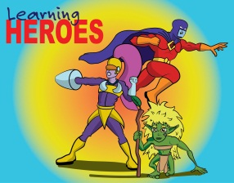
Learning Heroes – On 2nd December, in our achievement assembly, the following children were awarded as learning heroes
Yr 6; Jason, Bailey and Lucas.
Yr 5; Grace M, Yr 2; Sonny,
Yr 1; Phoebe and Taylor. Well done to all our children for showing their use of ‘building learning power’.

Author Huw Powell will be visiting school on January 12th, the launch date of his third Spacejackers book. All KS2 children will attend a session with him. Huw will be reading an extract from one of his books, drawing space characters, talking of his inspirations and answering questions. There will be a book signing after school when children will have the opportunity to buy one of Huw's books.

Parking considerately - Please can we ask parents and carers not to park over the residents’ driveways or in disabled bays. Thank you for your co-operation.

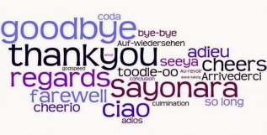
Goodbyes – We have three members of staff leaving us at the end of this term. Carol Mole, one of our catering assistants, Robyn Starkey, one of our dining hall assistants and Jenny Turnbull who is one of our Teaching Assistants in Reception. We wish them all well as they move onto pastures new.

Welcome – We have two new teaching assistants joining our team of support staff. They are; Susie Craney and Lisa Webb who both join us in January. We look forward to welcoming them to the Waycroft Multi Academy Trust.

Christmas Fayre - A huge thank you to the Friends of Waycroft for organising this year’s Christmas Fayre. As ever, it was a fun-filled family event. They made over £2,200 profit which is incredible. Thank you to all those parents and members of the local community who came along to give your support to this festive occasion. We hope you all enjoyed yourselves.

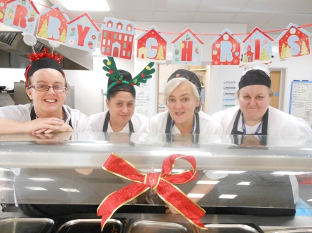
Christmas Lunches - Thank you to our catering team for the wonderful Christmas lunches they have cooked this year. Children have thoroughly enjoyed their turkey roasts and chocolate brownies.

Christmas Performances:
Thank you to all the children and staff for the fantastic Christmas Nativity, songs and readings that have taken place so far. It’s been lovely to hear all the positive feedback from parents and carers who have attended the events. We look forward to the final two carol concerts taking place tomorrow; Years 5 & 6 at 10am and Years 3 & 4 at 2pm. Both at Christ the Servant Church.

Message from the RRS Team - In 2015, the RRS team decided that Waycroft should join the OutRight Programme. This organisation works alongside Unicef to ensure that ‘The United Nations Convention on the Rights of the Child applies to everyone: whatever their ethnicity, gender, religion or abilities.’ (Article 2 of the UNCRC)
During our second ‘OutRight Day’ we focused on unaccompanied child refugees. We learned all about why some people become refugees and their lives as refugees. Year 5 children wrote to Amber Rudd, the Home Secretary, with some suggestions as to how these children can be helped. We are looking forward to her responses. 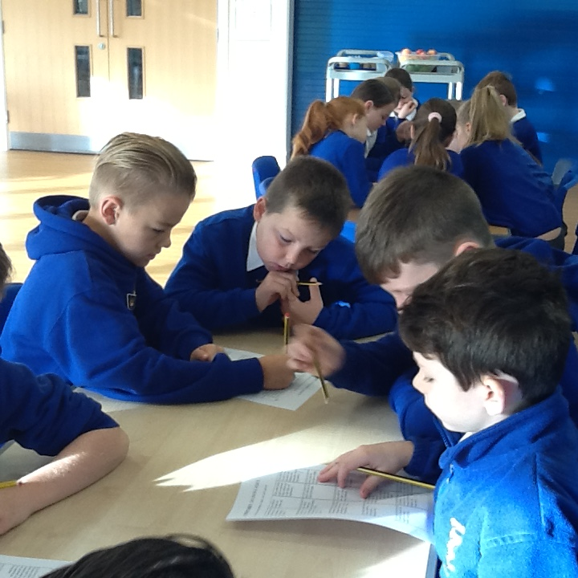

Reminder – Friday 16th December is an INSET day. Therefore the last day of Term 2 for children is this Thursday. School re-opens on Tuesday 3rd January 2017.

Open day – Tuesday 17th January. A chance for parents and carers to come and look round the school, view our displays and see the children at work. We will have two sessions; the first at 9.15am and the second at 1.30pm. Please note, that unfortunately, we cannot accommodate younger siblings on this date.

Blogging - Teachers and children are very excited about the new blogging project beginning this academic year. We are keen for our children to showcase their fantastic writing on a range of topics to be shared around the world. Our younger children will also be blogging pictures and information about the topics they are covering. Some classes have been trialling this but it is nearly ready to be launched across the school. Watch out in the New Year for information coming out to all parents/carers and details of our launch event. We are hoping you will be enthusiastic as the children and enjoy commenting on their blogs.

Everyone at Waycroft wishes all our families, children and friends a happy and peaceful Christmas and a joyful new year.

Yours sincerely
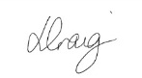
Lisa Craig
Head of School

